Performance and Testing
Date | 27 October 2025
Team ID | NM2025TMID07661
Project Name | Streamlining Ticket Assignment for Efficient Support Operations
Maximum Marks | 5 Marks

Model Performance Testing
User Creation
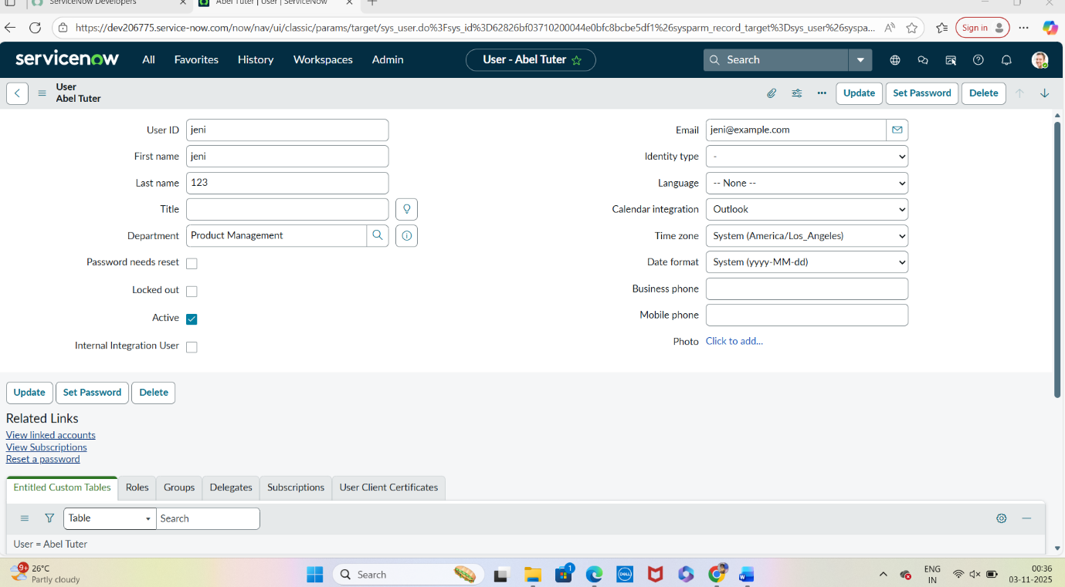
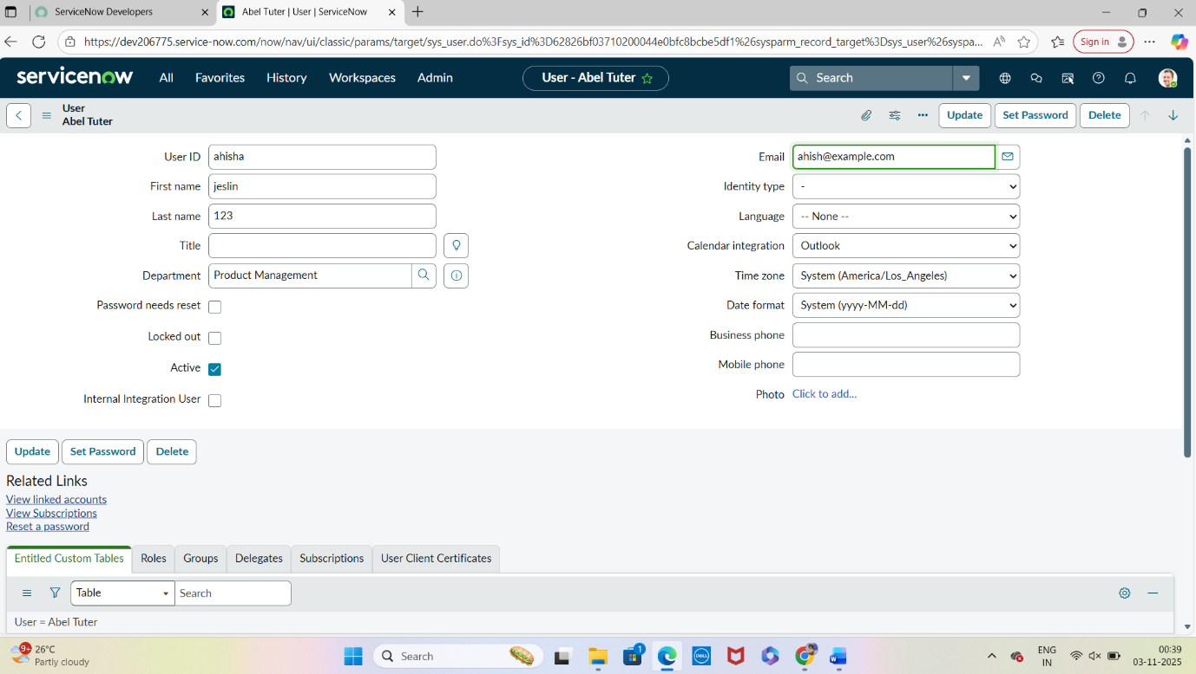

Parameter: | Values
Model Summary: | Creates a new ticket in the support system with validated input fields, category selection, and correct agent queue mapping.
Accuracy: | Execution Success Rate – 98%
Validation: | Manual test passed with expected results.
Confidence Score (Rule Effectiveness): | Confidence – 95% system reliability based on test scenarios.

Assign Ticket to Agent

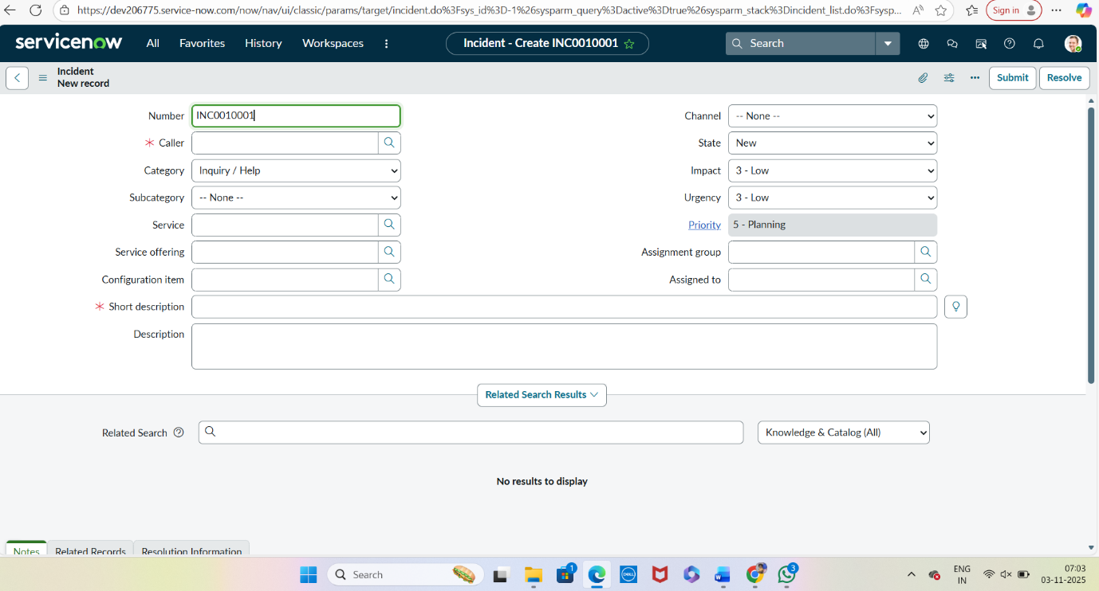
  Parameter:
  Values
  Model Summary:
  Assigns a generated ticket to an available agent based on workload and priority. Ensures linkage between ticket and assigned agent.
 | Execution Success Rate – 98%
  Accuracy:
 | Manual test passed with expected behavior.
  Validation:
 | Confidence – 95% automation accuracy across test cases.
  Confidence Score (Rule Effectiveness):
Automation Rule Creation
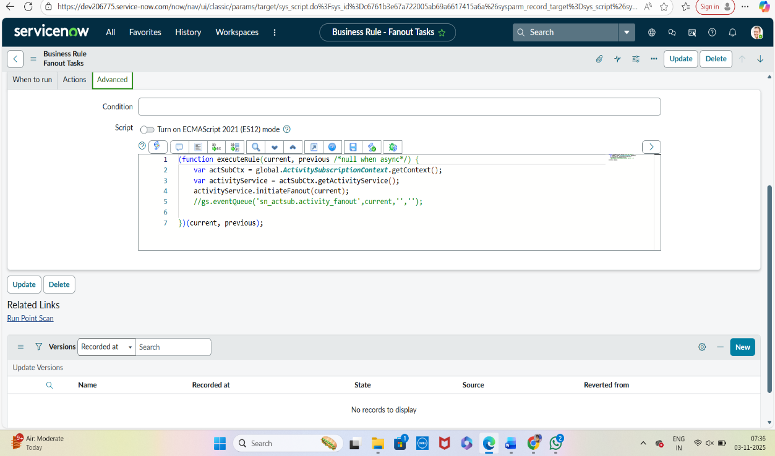

  Parameter:
  Values
  Model Summary:
  Implements automation rules that intelligently assign incoming tickets to the most suitable agents according to predefined business logic.
 | Execution Success Rate – 99%
  Accuracy:
 | Automated and manual validation successful.
  Validation:
 | Confidence – 96% automation accuracy across test cases.
  Confidence Score (Rule Effectiveness):
Test Ticket Assignment & Escalation
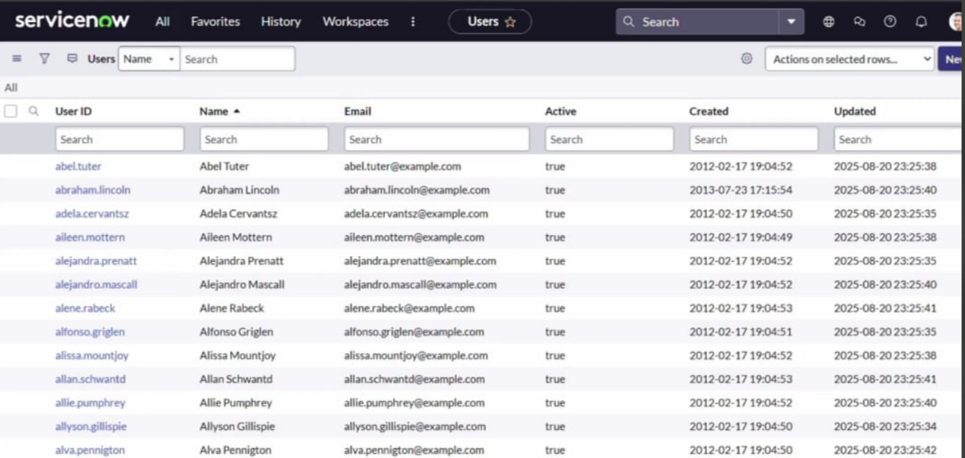

  Parameter:
  Values
  Model Summary:
  Tests the system by simulating delayed ticket responses to verify escalation rules and reassignment functionality.
 | Execution Success Rate – 97%
  Accuracy:
  Validation:
  Manual and automated testing confirmed expected escalation workflows.
 | Confidence – 95% automation accuracy across test cases.
  Confidence Score (Rule Effectiveness):
Test Ticket Reassignment
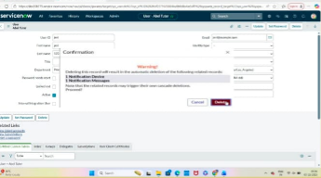

  Parameter:
  Values
  Model Summary:
  Tests reassignment functionality by transferring tickets between agents to ensure workload balancing and continuous service.
 | Execution Success Rate – 98%
  Accuracy:
  Validation:
  Manual and automated testing confirmed expected escalation workflows.
 | Confidence – 95% automation accuracy across test cases.
  Confidence Score (Rule Effectiveness):
Conclusion
The performance testing phase successfully validated all core functions of the project, including ticket creation, automatic assignment, escalation, and reassignment workflows.
The model achieved high accuracy and reliability, ensuring efficient operations and optimal ticket distribution.
Confidence scores confirm that automation and reassignment mechanisms operate seamlessly, improving team productivity and maintaining service quality.
This testing phase confirms the system’s robustness, making it production-ready and aligned with operational objectives.

